23CSE461 FULL STACK FRAMEWORKS
Name: JASHWANTH REDDY
Roll No: CB.SC.U4CSE23058
Shiva
1) use
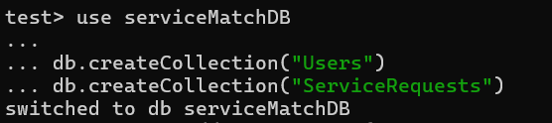
2) createCollection
3) insertOne
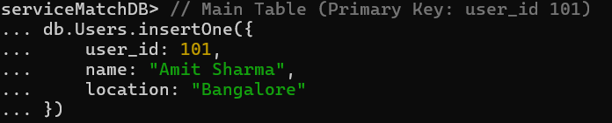
4) insertMany
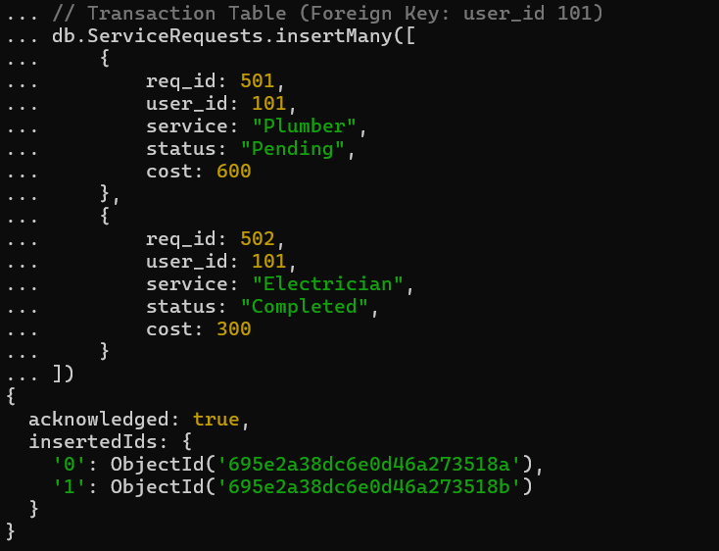
5) find
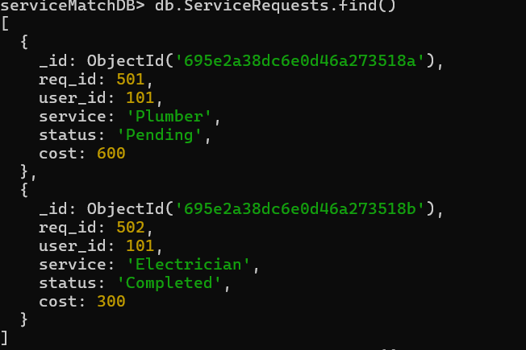6) find-and
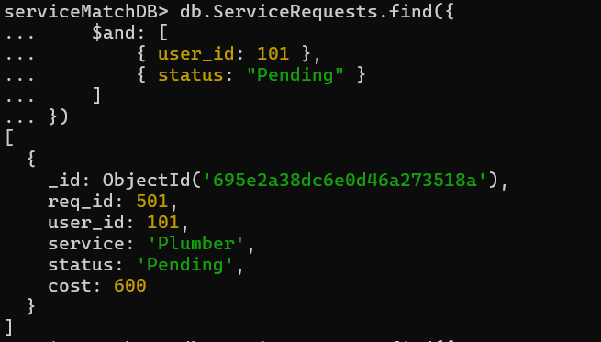

7) find-or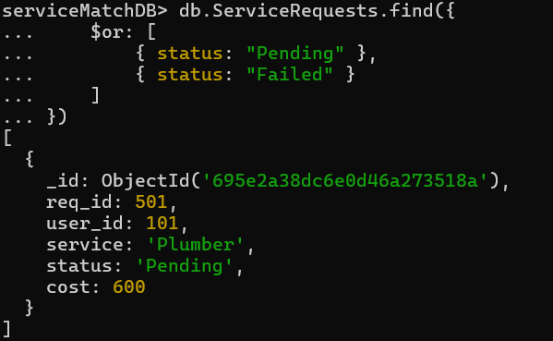
8) find-not

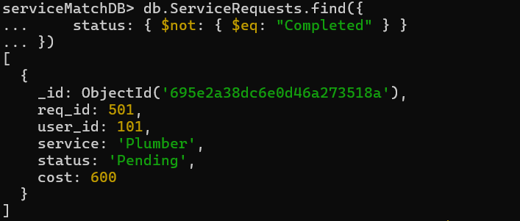

9) find-greater than
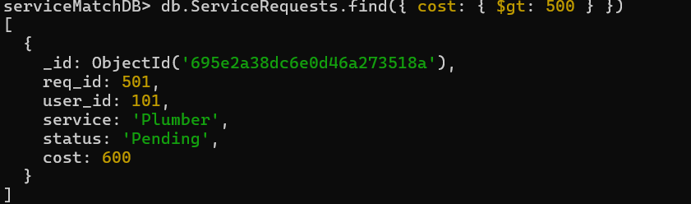
10) find-less than or equal to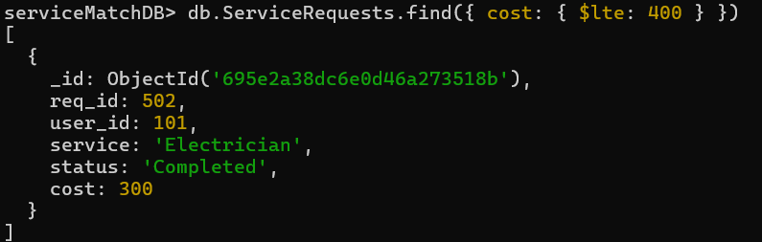
11) deleteMany
12) deleteOne13) drop
14) dropDatabase

